**Elevate labs SQL DEVELOPER INTERNSHIP**

**Task-1**

**____________________________________________________**

**Domain : employee management;**

### Entities:

1. **Employees**
2. **Departments**
3. **Jobs**

**Relationships:**

* Each employee belongs to one department.
* Each employee has one job role.
* One department can have many employees.

**Create tables:**

CREATE TABLE Departments (

department_id INTEGER PRIMARY KEY AUTOINCREMENT,

name VARCHAR(100) NOT NULL

);

CREATE TABLE Jobs (

job_id INTEGER PRIMARY KEY AUTOINCREMENT,

title VARCHAR(100) NOT NULL,

salary DECIMAL(10, 2)

);

CREATE TABLE Employees (

employee_id INTEGER PRIMARY KEY AUTOINCREMENT,

name VARCHAR(100) NOT NULL,

email VARCHAR(100) UNIQUE,

hire_date DATE,

department_id INTEGER,

job_id INTEGER,

FOREIGN KEY (department_id) REFERENCES Departments(department_id),

FOREIGN KEY (job_id) REFERENCES Jobs(job_id)

);

**Insert values:**

INSERT INTO Departments (name) VALUES

('Human Resources'),

('Engineering'),

('Marketing');

INSERT INTO Jobs (title, salary) VALUES

('HR Manager', 55000.00),

('Software Engineer', 75000.00),

('Marketing Executive', 50000.00);

INSERT INTO Employees (name, email, hire_date, department_id, job_id) VALUES

('Shamish', 'shamish@gmail.com', '2023-01-15', 1, 1),

('Surya', 'surya@gmail.com', '2022-10-01', 2, 2),

('Charan', 'charan@gmail.com', '2023-05-22', 3, 3);

**Outputs:**

**Departments:**

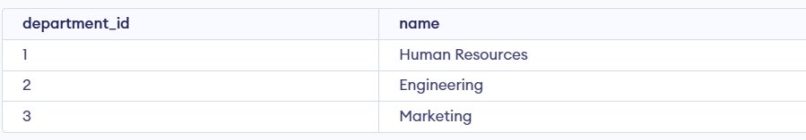

**Jobs:**

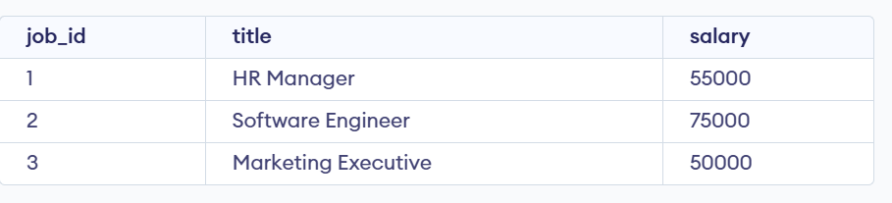

**Employee:**

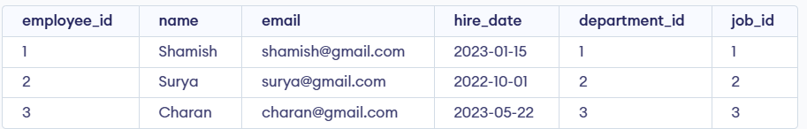

_____________________________________________________________________________________

**Name: Saivenkat Bodavula;**

**Email: saivenkat.bodavula@gmail.com.**